Digital Pension Support for employees
Brought to you by XXXXXX (Adviser name)

At XXXXXX (Adviser name) we believe in providing the very best of service to the employees of the pension schemes that we manage.
In our years of experience, we have found that many events occur during the scheme year that employees don’t get to hear about until the next renewal meeting, when it is too late to take action. This is why we are now providing all staff access to the Engage App.

Engage provides employees with user friendly pensions information, videos, links, articles of interest along with the facility to access your adviser at any time throughout the scheme year.

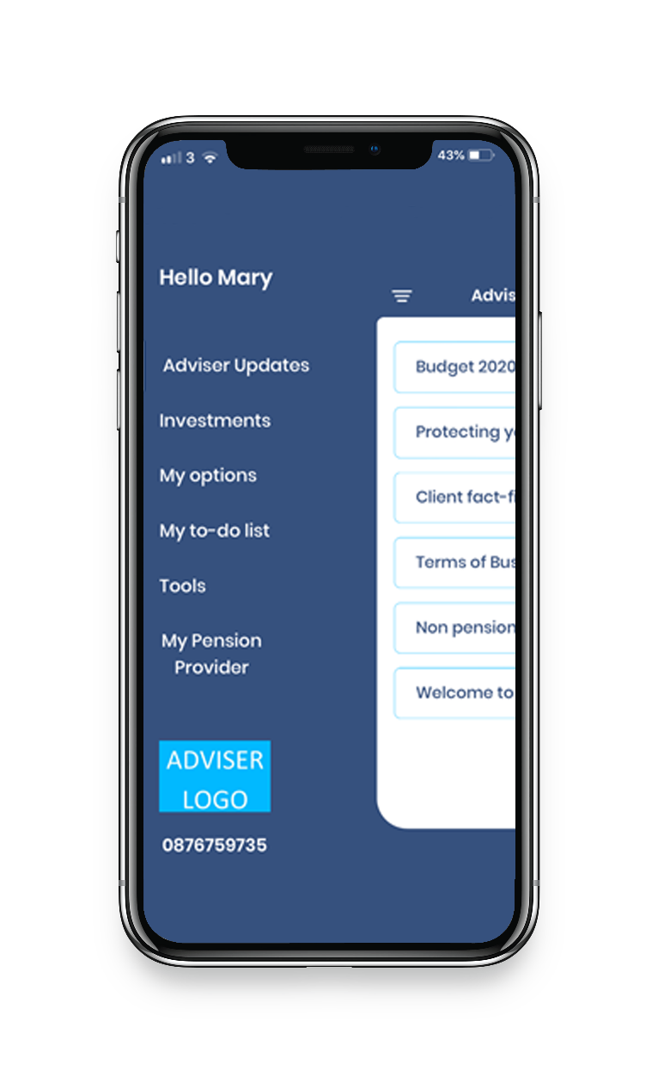

Employee App Features
Click to call

ADVISER LOGO

ADVISER
LOGO
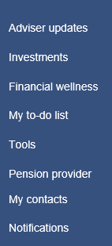

Access to you adviser when you need it
Search for lost pensions facility
Check your risk tolerance
Request a fund switch
Login into your pension’s providers portal
Videos and tools
Regular adviser updates
Financial to do list
Send tasks to your adviser

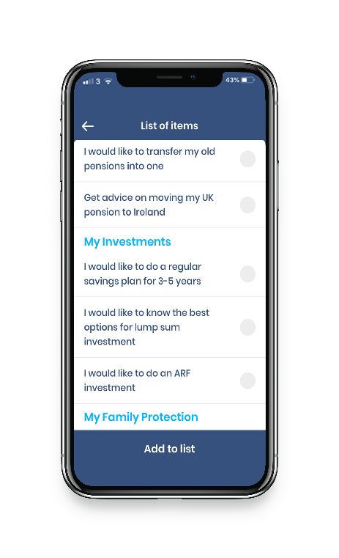
NOT SURE WHERE TO START?
The interactive to do list will suggest the steps you should take to help manage your pension and finances

Including…
Finally track down old pensions
Ensure you are maximizing tax relief
Ensure you have the best protection rates
Tax relief on income protection
Find the best savings options
Get the best return on investments
Add your own tasks and we will action them

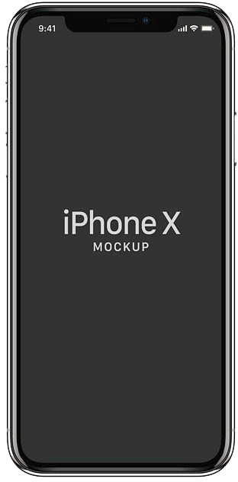

Tasks are sent automatically to your adviser who will be in contact to action them

EMPLOYEE ENGAGE APP
Frequently Asked Questions

What is the Engage App?
Engage is an employee smartphone application provided by your adviser designed to help staff engage more with their pension scheme.

The Engage App allows the adviser to communicate with staff not just at renewal but throughout the year on important matters such as volatility in stock markets, close to tax deadline, when to consolidate old pensions etc.

The App provides a host of useful pension information, videos, links etc. to enhance the value that staff get from the scheme.

Is the App available to all scheme members?
Yes, all scheme members, (including ex staff) can access the App once they are members of the pension scheme (active or deferred). Your adviser will provide you with your access code.

Is staff data stored on the App?
No employee data is stored on the App. There is no threat to data security or any GDPR implications should a staff member lose the phone device.

What are the benefits to HR of staff using the App?
In addition to reducing HR queries, the App significantly increases staff engagement, value, and appreciation that staff have for the pension scheme. As staff can now communicate with their adviser throughout the year, they get more from the pension scheme, improve their finances, and help reduce financial stress.

Are there disadvantages to staff if they don’t use the App?
If you decide not to use the App will still have the opportunity to discuss your pension at the annual review meetings which will happen as usual. There may be communications throughout the year sent out to App users which we may not be able to send by post /email. You could therefore miss some important communications or opportunities.

How do I get started?
Simply e-mail download the App from the Appstore or Google Play Store:
- Register using the code that we provide you with
- You’re all ready to go

