ADVISER LOGO

Investment Considerations
The whole point of making investments is to earn good returns from them. However, it cannot be denied that investments do lose their value sometimes.

Following are some key points that can help you reduce that risk considerably:

Income expectation
You should know the main purpose behind making any investment. This should be your primary consideration when putting your hard-earned money at stake. You must figure out whether you wish for long-term capital gains or immediate cash flow.
Your risk appetite
The amount of money you make with your investments will depend on the amount of risk you’re ready to take. When we talk about risk, there are two important components that should be taken into account: the extent of money at stake and the chances of a loss actually happening. Usually higher risk translates into more income or better growth. So, pay good attention to your risk appetite before investing.
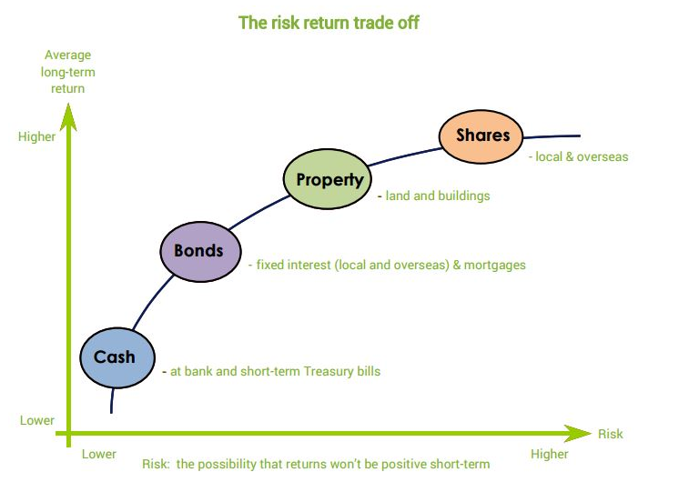

Liquidity of the investment
Liquidity is another important aspect you must pay heed to before investing any money. If you have a specific amount of savings and are certain that you’ll not need those funds for another five years, you can tie them up in some investment for that much time and earn good returns. However, keep in mind that should you need that tied up money in the wake of some unexpected circumstances, you may have to pay major penalties for freeing it up. As an alternative, you can invest into liquid securities which can be sold any time. It’s good to select your investments based on your need for liquidity, growth and income.

Growth prospects
Retirees usually invest into bonds for supplementing their pension income. Young investors seek growth from their investments and are often willing to invest every last bit of spare cash to make their investments grow. People who’re hard-core growth-oriented investors focus only on stocks which they believe will appreciate in value over a period of time, so they can book profits later. Some of the exotic investment products that promise good growth are commodities, futures and foreign exchange.

Please note that the above is just an outline and does not constitute financial advice. You should not make a financial decision without having a review of your personal circumstances.
Please contact us to discuss your options
Adviser Logo

