

*Engage*

**Employee Pension & Financial Wellness App**

Staff login details

**Download**

|  |  |  |
| --- | --- | --- |
| **Location** | **Name of App.** | **App Icon** |
|  |  |  |
|  | **Centric Engage Pensions** |  |
|  |  |  |
|  | **Engage Pensions** |  |







**Register**

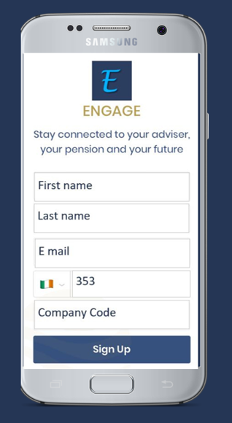

**Your Access details**

**Employer Scheme: _______________________**

**Company Code: _________________________**

Access questions?

E mail info@centric.ie

Adviser logo